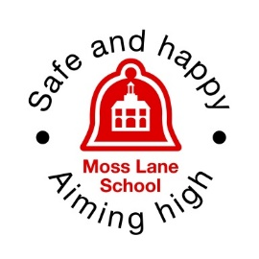
Our value of the term
Moss Lane School Newsletter
Friday 10th July 2026
Whole School Attendance
96.24%

Dear Families,
As we start to come to the end of another successful academic year, I have taken time to reflect on the many adventures, achievements and memorable experiences our children have enjoyed. From visits to Brooklands, Wisley and The Look Out Discovery Centre, to theatre trips, animal encounters, Woodland School sessions and our exciting Wow Days, every opportunity has helped to spark curiosity, deepen learning and create lasting memories. It has been a pleasure to watch the children embrace these experiences with such enthusiasm, and they should all feel immensely proud of everything they have accomplished this year.
A heartfelt thank you goes to our incredible staff team, whom I am privileged to lead. Their dedication, creativity and unwavering commitment to our children make Moss Lane the special place it is. I would also like to thank you, our families, for your continued encouragement and support throughout the year.
Moss Lane is so much more than a school – it is a caring and vibrant community. The support we receive from parents, governors, staff, the PTA, our children and the wider community plays a vital role in everything we achieve. I firmly believe that the partnership between home and school is at the heart of our success, and I am truly grateful for the trust, kindness and commitment you show every day.
To all of our children, thank you for your hard work, resilience, enthusiasm and determination. You have challenged yourselves, supported one another and made us proud in so many ways. I would also like to recognise our School Council, Eco Council and Behaviour Mentors. Thank you for representing your classmates so thoughtfully, sharing your ideas and helping to make our school an even better place. Your leadership and commitment have been outstanding.
A very special mention goes to our wonderful Year 2 children. You have been exceptional role models and ambassadors for Moss Lane, and we will miss you enormously. As you begin the next exciting chapter of your education, we wish you every success and happiness. Remember that you will always be part of the Moss Lane family, and we look forward to hearing about all that you achieve in the future. We also send our very best wishes to any families in other year groups who are moving on—you will all be greatly missed.
We are now looking forward to a well-earned summer break before returning refreshed, re-energised and ready for another exciting year of learning and growth. We look forward to welcoming our Year 1 and Year 2 children back to school on Wednesday, 2nd September 2026.
Wishing you all a joyful, safe and sunny summer holiday. And to all our children—stay safe, make wonderful memories and, most importantly, have lots of fun!
Warmest wishes,

Victoria Abbott

Headteacher

What’s been happening in School

Year R
Reception have been celebrating the completion of their Independence Challenge! We are very proud to see the children carrying their own belongings and becoming increasingly able to manage themselves. Remember that Bees are welcome to wear their yellow pin badge to school!
Year 1
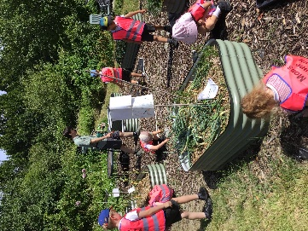
Foxes Class had a great time at the allotment harvesting the crops to sell at the summer fair. They couldn't believe the size of some of the onions!!
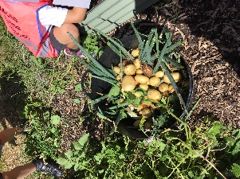
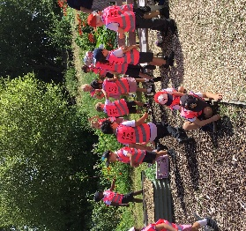

Year 2
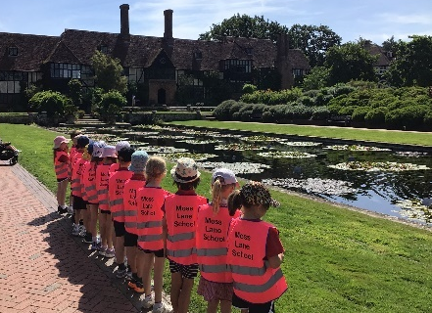
Year 2 had a fantastic time on their school trip to RHS Wisley last week. The Year 2 team wanted to say a big thank you to the parent helpers that were a part of ensuring the day ran smoothly, and a big thank you to the PTA for our fancy new hi-vis vests! We really looked the part and even had member of the public sharing their enthusiasm about our school and the children's excellent behaviour.
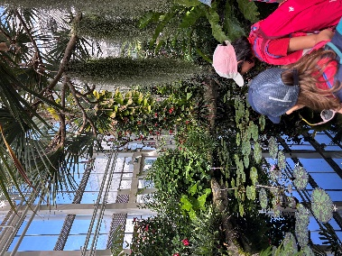
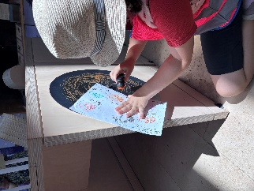

Welcome Talks
WEDNESDAY 16th SEPTEMBER
The aim of these talks is to provide a brief overview of the year ahead with regards to general procedures i.e., home learning, reading and the curriculum.

Year 1 =6:00pm in Otters
Year 2 =6:30pm in Foxes
Year R= 7.00pm in Bees

Open Afternoon
On Wednesday 9th July, we were delighted to open our doors for our annual Open Afternoon. It was wonderful to welcome so many parents, families, members of the Godalming community and, of course, our new families who will be joining Moss Lane in September.
The afternoon was a fantastic opportunity to celebrate everything the children have achieved this year. Every classroom was filled with examples of their hard work, creativity and progress, and it was lovely to see the children so proudly sharing their learning with family and friends.
A huge thank you goes to our amazing staff, the PTA, our parents and, of course, our wonderful children for helping to make the afternoon such a success. Events like these take a great deal of planning and teamwork, and we are incredibly grateful to everyone who played a part.
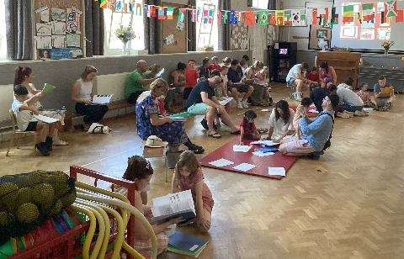
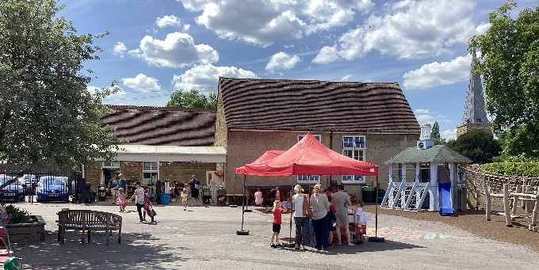
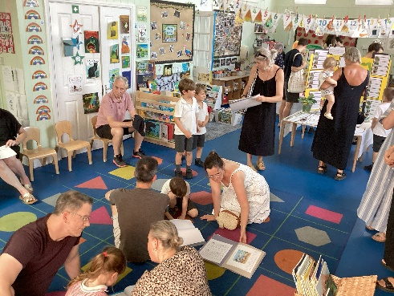
One of the things that makes Moss Lane so special is our strong sense of community. We always enjoy welcoming visitors into our school and sharing all that we have achieved together. Thank you to everyone who came along and helped make the afternoon such a memorable celebration of another wonderful year at Moss Lane.

Summer Fair…
What a fantastic afternoon we had at our Summer Fair! We are incredibly grateful to everyone who attended and helped make the event such a wonderful success. The glorious weather created the perfect backdrop for an afternoon of fun, laughter and community spirit.
This year's retro-themed fair was packed with traditional games and activities, including bean bag toss, giant Connect 4, giant Jenga, giant Tetris, noughts and crosses, raffle, The Great Moss Lane Bake off and a variety of stalls, providing something for everyone to enjoy.
A very special thank you goes to our incredible PTA, particularly Chair Elizabeth Holliday and Vice Chair Roxanne Clark, whose dedication, enthusiasm and countless hours of hard work made the event possible. We are also extremely grateful to Secretary Anneliese Protheroe, Treasurer Rhian Easterling, committee members Jen Jupe, Isabel Matias, Mary McAllen and Mel Orchard, along with our Teacher Representative, Miss Fox. Your commitment to our school community is truly appreciated.
Our sincere thanks also go to Durleighmarsh Farm for their generous donation of fresh fruit and to one of our parents for kindly printing all of our display materials. Congratulations to the bake-off winner’s children: Elodie Year 2 and adult winner Kirstin – Bee parent. We are very grateful to our governors for giving their time to help with the delicious barbecue, and to all of the parents and volunteers who supported the event by organising, setting up and running stalls throughout the afternoon.
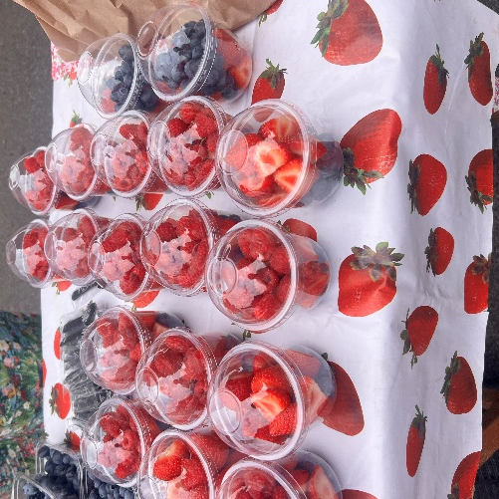
Most importantly, thank you to everyone who came along to support the fair. We are delighted to share that we raised approximately £3000, which will be used by the PTA to enhance opportunities and experiences for all of our children.
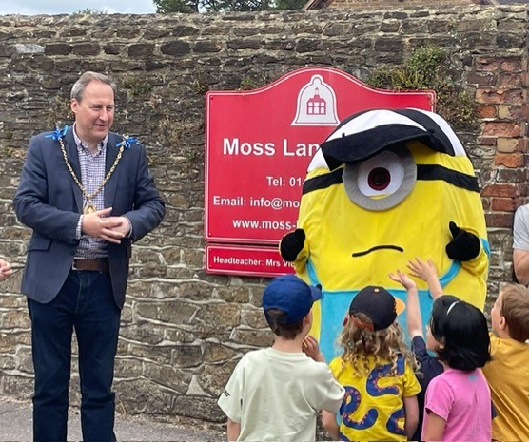

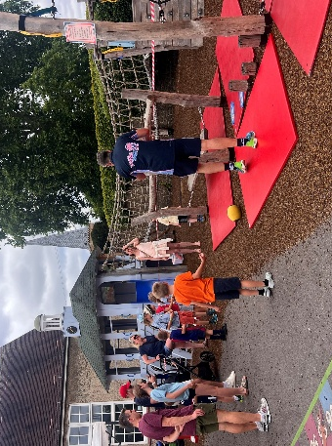
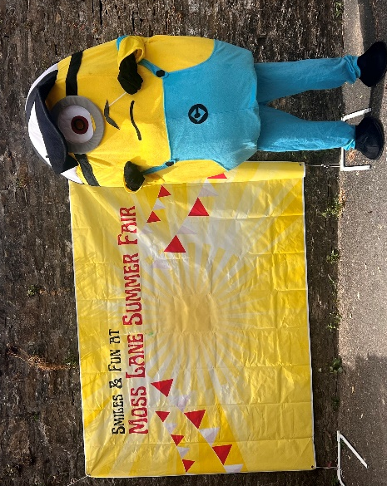
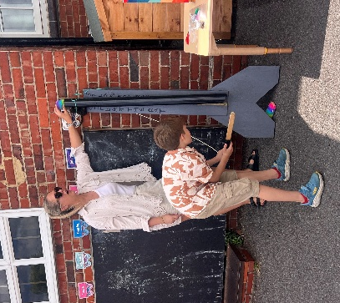
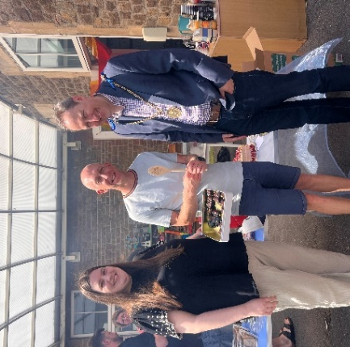
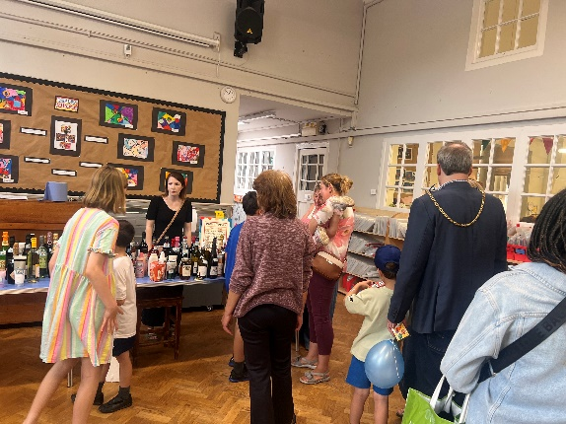

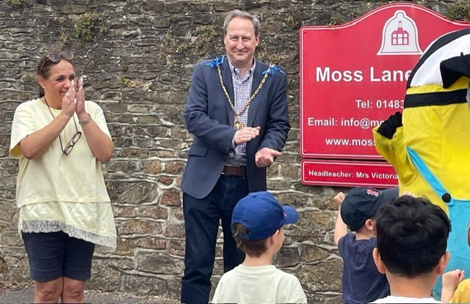

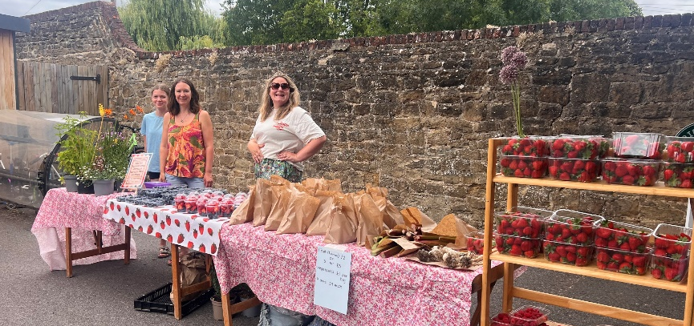

GLP art exhibition
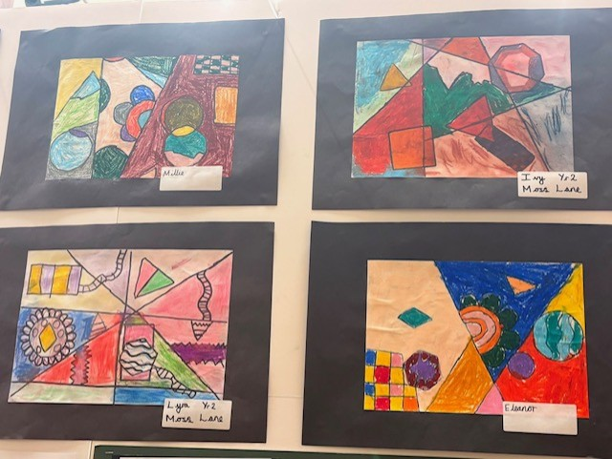
We were delighted to take part in this year's GLP Art Exhibition alongside the other schools in the partnership. The exhibition showcased an outstanding collection of artworks, highlighting the creativity, imagination and talent of pupils across all participating schools. Our children produced some truly fantastic work, and we are incredibly proud of their achievements. It was wonderful to see so many families and members of the community attending to celebrate the children's artistic successes. Thank you to everyone who came along to support the event and help make it such a memorable occasion.

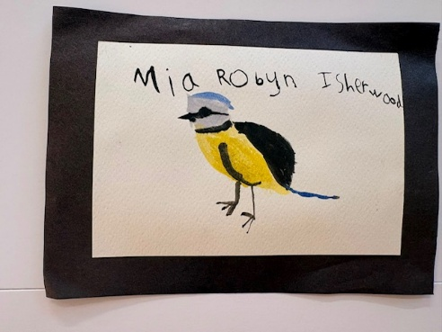

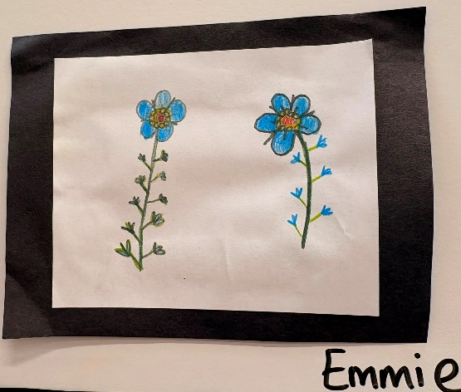
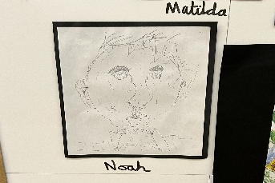

What’s coming up this term …
Friday 10th July  PTA movie night  Monday 13th July  An optional parents' evening if you want to talk about your child’s report  Rescheduled Sports Day – various times  Thursday 16th July  Leaver’s disco  (Please note the change of date)  Monday 20th July  Leaver’s Assembly at 2.30pm  Tuesday 21st July  PTA break to the rule Day!  Wednesday 22nd July  End of term 1.30 pm finish   | 2026-2027    Tuesday 1st September  INSET DAY  Wednesday 2nd September  Children return to school  Wednesday 2nd -4th September  EYFS Home Visits  Monday 7th - Friday 11th September  EYFS in school  AM= 8.45am to 11.00am  PM= 1.05pm- 3.20pm  Monday 14th - Friday 18th September  All EYFS in school am and lunch  8.45am-1.15pm  Wednesday 16th September  Welcome Talks  Monday 21st September  All EYFS in all day 8.45am- 3.20am  Half term  Monday 19th October- Sunday 1st October  (NB It is a 2-week half-term)  End of term  Friday 18th December 1.30 pm finish  Start of term  Monday 4th January 2027

Sports day
Although we were disappointed that the hot weather meant we had to cancel our planned Sports Day, we were determined that the children would not miss out. Instead, each class will enjoy their own sports activities and challenges on the playground on Monday 13th July, ensuring that everyone still has the opportunity to take part, have fun and celebrate being active. It is a shame that we are unable to come together as a whole school, but with so many other events taking place at this busy time of year, it is the best solution. A huge thank you to our PTA for kindly providing ice lollies for all of the children, which will be very much appreciated and a perfect treat after all of the sporting activities.
We are also grateful to Miss Betterton and all of our staff for their flexibility and enthusiasm to make sure the children still enjoy a memorable day despite the change of plans.


Please see your class times below.
9am – 9.40am – Bumblebees and Honeybees combined
9.50am – 10.30am - Squirrels
11am – 11.40am – Foxes
1.20pm – 2pm – Hedgehogs
2pm – 2.40pm – Otters

Important notices and reminders

Club4 Holiday Activities Summer Holidays Fun 2026 Book Now
Give your child an unforgettable Summer with Club4, part of the national Holiday, Activity and Food (HAF) Programme. This initiative gives eligible children from Reception to Year 11 fully-funded high-quality holiday activities—all including a nutritious meal each day.

With 200+ locations across Surrey, there’s something for everyone this summer. From high-energy sports and team games to hands-on cooking, creative arts, outdoor adventures and themed activities – Club4 camps are packed with fun.
Teens can enjoy dedicated days out, wellbeing sessions and even a free month’s gym & swim access, while families can join relaxed stay-and-play sessions and exciting Leisure Centre activity days.
Club4 camps are packed with fun-filled opportunities every Easter, Summer and Winter, giving children the chance to explore new interests, build confidence, make friends and create lasting memories in a safe and welcoming environment.

How to book:
- Bookings open on Tuesday 30 June – but why wait? Register your interest with activity providers today to make sure you don’t miss out! You’ll get an email one hour before bookings open, giving you early notice and the best chance of securing your preferred activities.
- Scan the QR code or click the booking link: https://www.eequ.org/club4activesurrey

Let’s make this holiday active, joyful, and truly memorable for your child!
Club4 Team. Please see attached guide for parents.

Spotlight on Safeguarding

Are you concerned about a child?
Please share your concern with one of our safeguarding leads:
Mrs Abbott dsl@moss-lane.surreey.sch.uk, Miss Betterton, and Miss Forbes Wood.
If urgent and out of school hours please contact:

Surrey Children's Services C-SPA 0300 470 9100 cspa@surreycc.gov.uk

Safeguarding during the summer holidays

During the school holidays, the safeguarding team only monitors their email periodically. If a child is in immediate danger, call 999. If you have a concern about a child or young person being abused or neglected, or an adult who is concerned about a young person's safety and wellbeing during the weekend or school holidays, please remember that you can contact Surrey Children's Services' Single Point of Access, also known as CSPA. Lines are open between 9 am and 5 pm from Monday to Friday. The telephone number for CSPA is 0300 470 9100; for out-of-hours emergencies, the number is 01483 517898.https://www.surreycc.gov.uk/social-care-and-health/childrens-social-care/contact-childrens-services rather than waiting for a reply here.
Children and young people can contact Childline free and confidentially on 0800 1111.
Parents and carers can contact the NSPCC helpline on 0808 800 5000.
If a child or young person is struggling with their mental health, they can text YM to 85258 for free, 24/7 crisis support.
Parents wanting advice can also contact the YoungMinds Parents Helpline on 0808 802 5544.
Safeguarding and AI
AI is being used to turn ordinary photos of children into sexual abuse material. The National Crime Agency and Internet Watch Foundation have issued new guidance to help parents make informed choices about sharing images of their children online. It covers reviewing privacy settings, revisiting consent with your child as they grow, and what to do if you're worried. The parents' guidance can be found here: https://www.iwf.org.uk/resources/ai-child-abuse-imagery-parent-guide/

Important Safety Reminder
Please can we ask all parents and carers to ensure that their children do not touch the green emergency exit buttons located on the playground gate and just inside the front entrance. These buttons are for adult use only and form part of our site's safety and security systems. We would also kindly ask parents not to point out or demonstrate the buttons to their children. While many children may already have noticed them, we do not wish to draw unnecessary attention to their purpose or location.
Thank you for your support in helping us keep everyone safe and maintain the security of our school site.

Book Amnesty…
Our school library books are important to our children and us. Throughout the year, many books are lost at home or are not returned. These books are very expensive to replace so please join our book amnesty and return any books that you find at home that belong to us.

Start of Autumn term 26-27
- Children return to school after the holidays on Wednesday, 2nd September
Please note that this date might be different from other local Schools as we now follow Surrey term dates.
- Half term-Monday 19th October- Sunday 1st October

(NB It is a 2-week half-term)
- End of the autumn term, December 18th at 1.30 pm.

Local Events

Charlie’s Promise

Charlie’s Promise is a local charity that was established in memory of Charlie, a local young man who very sadly lost his life to knife crime in July 2023 at the age of 17. On 15th August, Charlie’s Festival will be taking place at Jubilee Fields in Milford. The event promises to be a fun-filled day for all ages, featuring live music, inflatables, games, food, ice cream and much more. At its heart, the festival aims to bring people together in support of young people and positive change within our community. This charity holds a special place in the hearts of the Moss Lane community, as Charlie’s older brother, Adam, previously worked at Moss Lane, teaching PE and running our Breakfast Club. We wish the organisers every success with what promises to be a wonderful and meaningful event.

Charlie's Festival
When - 15th August, 12 noon - 10pm

​​
Where - Jubilee Field, Milford, GU8 5HQ
​
What - Live music all day, with an amazing line up. Fun for all the family, more food than ever, bigger prizes, more than ever before!
​
Why - For the local community to come together and remember Charlie and other victims of knife crime.

